General background

* IBS = Irritable Bowel Syndrome
* The prevalence, patterns and impact of irritable bowel syndrome: an international survey of 40,000 subjects – IBS affects 10 to 15 percents
* Diagnosis and management of IBs – Diagnose mostly based on symptoms *and treatment (neurotransmitter something) – colonoscopy and lab test are normal*
* Diagnosis and management of IBs – 3 subtypes
* New Insights into the Pathophysiology of Irritable Bowel Syndrome: Implications for Future Treatments - Altered motility, visceral hypersensitivity, abnormal brain–gut communications, autonomic dysfunction, and immune activation may all be involved in the pathophysiology of IBS.

*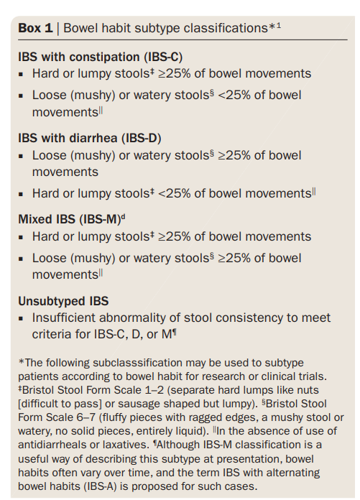*

* Romes criteria?
* THE IRRITABLE BOWEL SYNDROME – Therefore, the irritable bowel syndrome can be reasonably diagnosed on the basis of flexible sigmoidoscopy alone, in patients who are less than 50 years old, or colonoscopy, in those who are 50 or older; barium enema and flexible sigmoidoscopy are often substituted for colonoscopy. In patients with diarrhea, a biopsy specimen should be obtained from the mucosa of the descending colon to rule out microscopic colitis.

Current state of the field

* A clinician’s guide to microbiome analysis – literature review to start
  + Thenstrongest links between altered microbiome function and human health or disease arguably involve bacterial metabolites but, even in those cases, most of the evidence relies on correlation between an altered microbiota and pathophysiology, rather than a demonstrated microbial causative mechanism.
  + Complex communities of microorganisms live on and in the human body, and variations in the composition and function of these communities are increasingly linked to various conditions and diseases
  + Although it is not known if microbiome changes are causative or consequential in most pathophysiologies, they might provide biomarkers for disease detection or management
  + Microbiome analysis is likely to become a routine component of secondary health care and is emerging as a modifiable environmental risk factor in multifactorial diseases that could be targeted by novel therapeutics
  + Technology advancements are leading to a range of powerful methods for microbiome analysis becoming available and affordable for clinical studies
  + Judicious choice of sample type and sequencing platform are required to maximize the clinical utility of microbiome data
  + No standardised methods
  + Terms might be different from other papers
  + 16S for prokaryotes & 18S for eukaryotes
  + Faecal samples
  + If investigating a new clinical question, the difference between faecal and mucosal microbiota should be kept in mind, especially if aiming at microbiome-related diagnostics or biomarkers.
  + 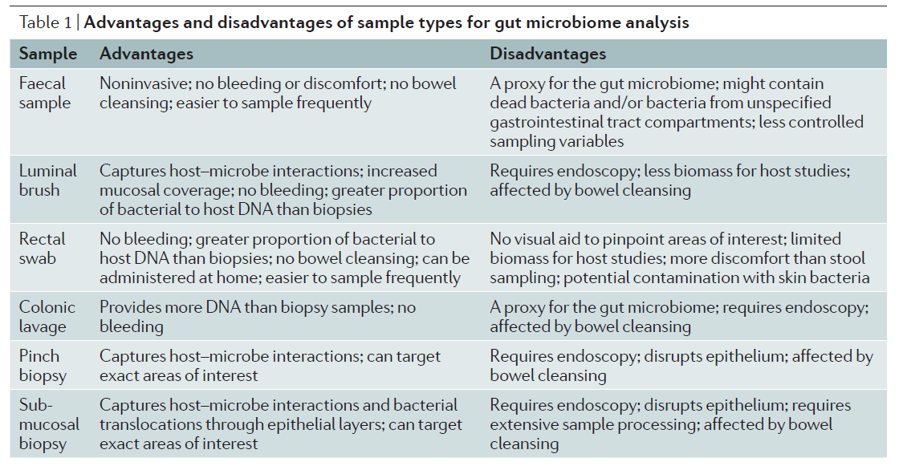
  + sequence-based microbiome – who is there
  + metagenomics – what can they do – phylogenetics – rely on accuracy of databases
  + metatranscriptomics – what are they doing
  + rRNA – who is active

Knowledge gaps

Clear statement of aims of review

Detail of specific method

How this method fits with alternatives

Compare and contrast method with alternatives

* An excess of prior irritable bowel syndrome diagnoses or treatments in Celiac disease: evidence of diagnostic delay
* The Manitoba Inflammatory Bowel Disease Cohort Study: Prolonged Symptoms Before Diagnosis—How Much Is Irritable Bowel Syndrome?
* <https://iffgd.org/wp-content/uploads/IBSinRealWorld_Final.pdf> - 43% suffered five or more years before diagnosis

Clinical relevance

Implications for the field